- 装上 应用 m3s_api_server.apk
- 在文件中导入 import com.qnbar.library.ICustomApi;
- 建立连接：

private static final String ACTION = "action.qnbar.api";

Intent intent = new Intent(ACTION);
intent.setPackage("com.qnbar.library");
bindService(intent, serviceConnection, Context.BIND_AUTO_CREATE);

private ICustomApi iCustomApi;

private ServiceConnection serviceConnection = new ServiceConnection() {
@Override
public void onServiceConnected(ComponentName name, IBinder service) {
Log.d("ApiService", "onServiceConnected");
iCustomApi = ICustomApi.Stub.asInterface(service);
}
@Override
public void onServiceDisconnected(ComponentName name) {
Log.d("ApiService", "onServiceDisconnected");
}
};

接口：

/**
* 静默安装
* @param path
*/
void silentInstall(String path);
/**
* 静默卸载
* @param package
*/
void silentUnInstall(String packageName);
/**
* 切换信号源
* @param signalSourceName
*/
void changeSignalSource(String signalSourceName);
/**
* 设置开机动画
* @param path
*/
void setBootAnimation(String path);
/*** 返回hdmi列表
*
*/
List<String> getHdmiList();

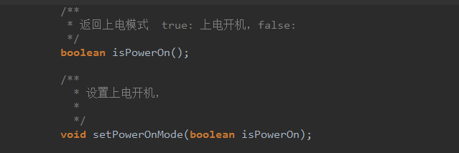



打开系统设置：
